**WEEKLY PROGRESS REPORT**

Allayssa George A. Dela Cruz

Week #: 1

*June 25 – June 26, 2021*

On June 25, 2021, the quality management system team was divided into six groups. I was grouped together with Ms. Carmila Guillen and Ms. Glyde Arabejo. We were assigned to create a Mockup Landing Page for the quality management system website. So, we planned to create individual layouts and designs. On June 26, 2021, after we were finished with the individual work, we criticize our works and if some designs are good in the others, we placed them such as color, font face, and shapes. Then after we are satisfied with our work, we uploaded the design and put it on the "For Review" board.

Noted By:

Mishill D. Cempron

Supervisor

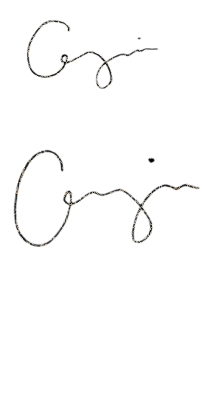Prepared by:

Allayssa George A. Dela Cruz

On the job trainee